Lost Pet
REWARD $400.00
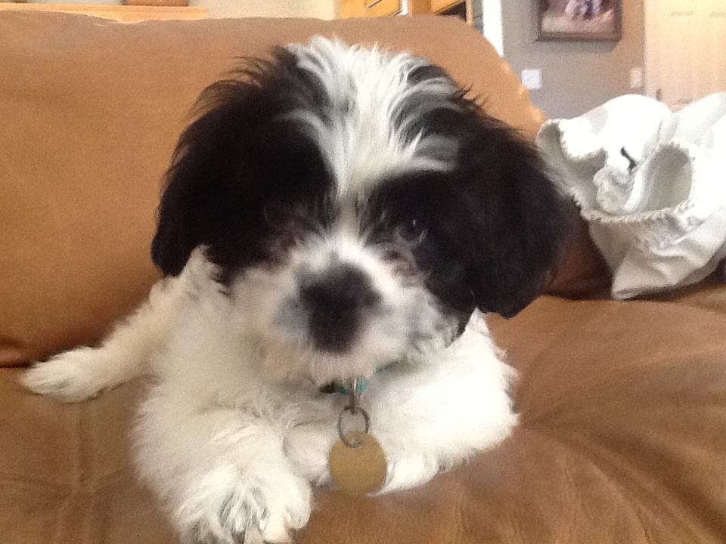
"Moji" puppy
Identifying marks: black and white eyes black spots. Answers to his name. He needs medicine right away tag still says Mars, family misses her.
Last seen: 3541 Apache Road - Nov 30th 5:00 p.m.
Contact (209) 795-1658
Email: andy.mcgrath4321@gmail.com

